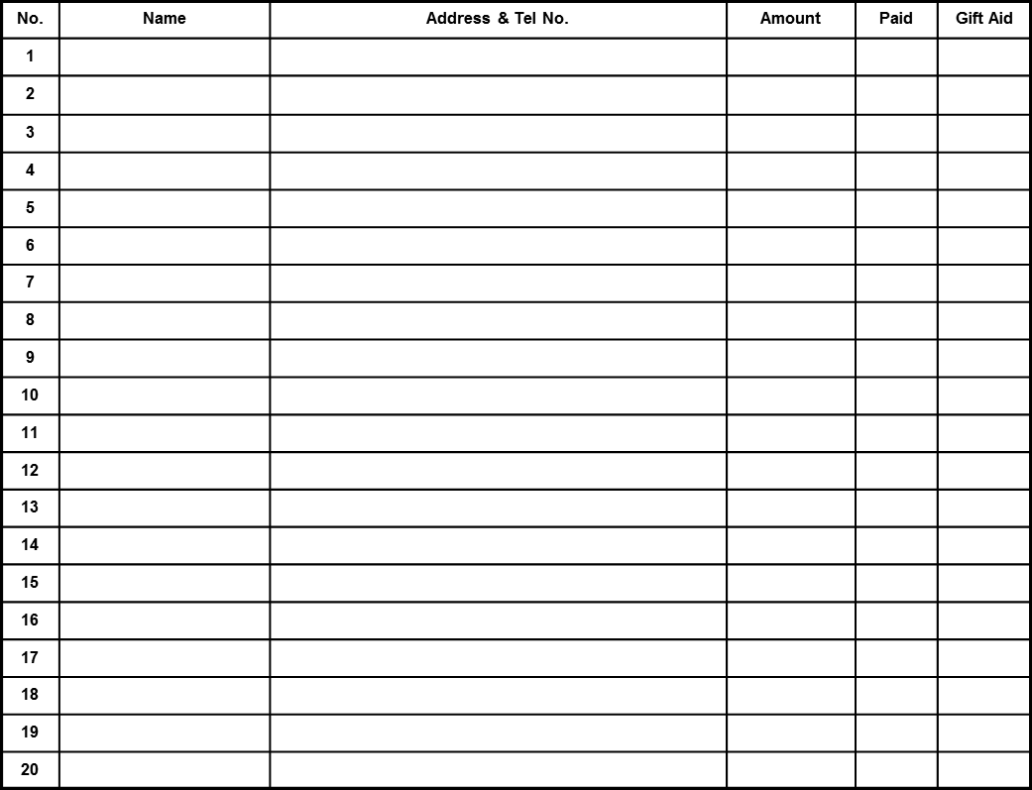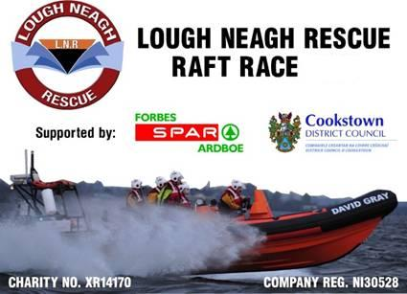

Please note all sponsorship monies raised will go directly to Lough Neagh Rescue, to maintain rescue & emergency services throughout Lough Neagh. This charity is funded by voluntarily contributions and through events such as this Raft Race & the crew personally thank you for your donation.

**If you are using the gift aid section you must fill in the attached gift aid certificate & return it with your sponsorship form & monies. Registered charity number XR14170**

**Lough Neagh Rescue Raft Race**

**Ballyronan Marina ~ Fri 24th August 2012**

For full event details, more entry & sponsorship forms please visit:

www.loughneaghrescue.co.uk

or Contact Paul Duffy on 07765886581

Connor Mc Guckin on 07725162008

**Sponsorship Form**

**All sponsorship money must be received prior to or on race day.**

Minimum Sponsorship required to enter each raft is £100