THE PIRATES ARE COMING!

The Pirate Boat Challenge is a
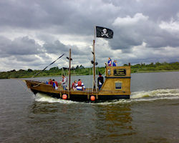
team fundraising event in aid of
Lough Neagh Rescue.

Teams will compete by racing
Pirate boats against each other
along the Six Mile Water River to
become the champion of champions!

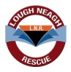
Teams will also have the opportunity to compete in a ‘Knockout’ Challenge.
The boats are replica Pirate ships, ten metres in length and are crewed by two Pirates and your team of eight oarspeople.

Each team will race against the clock and the quickest teams will go through to a grand finale.
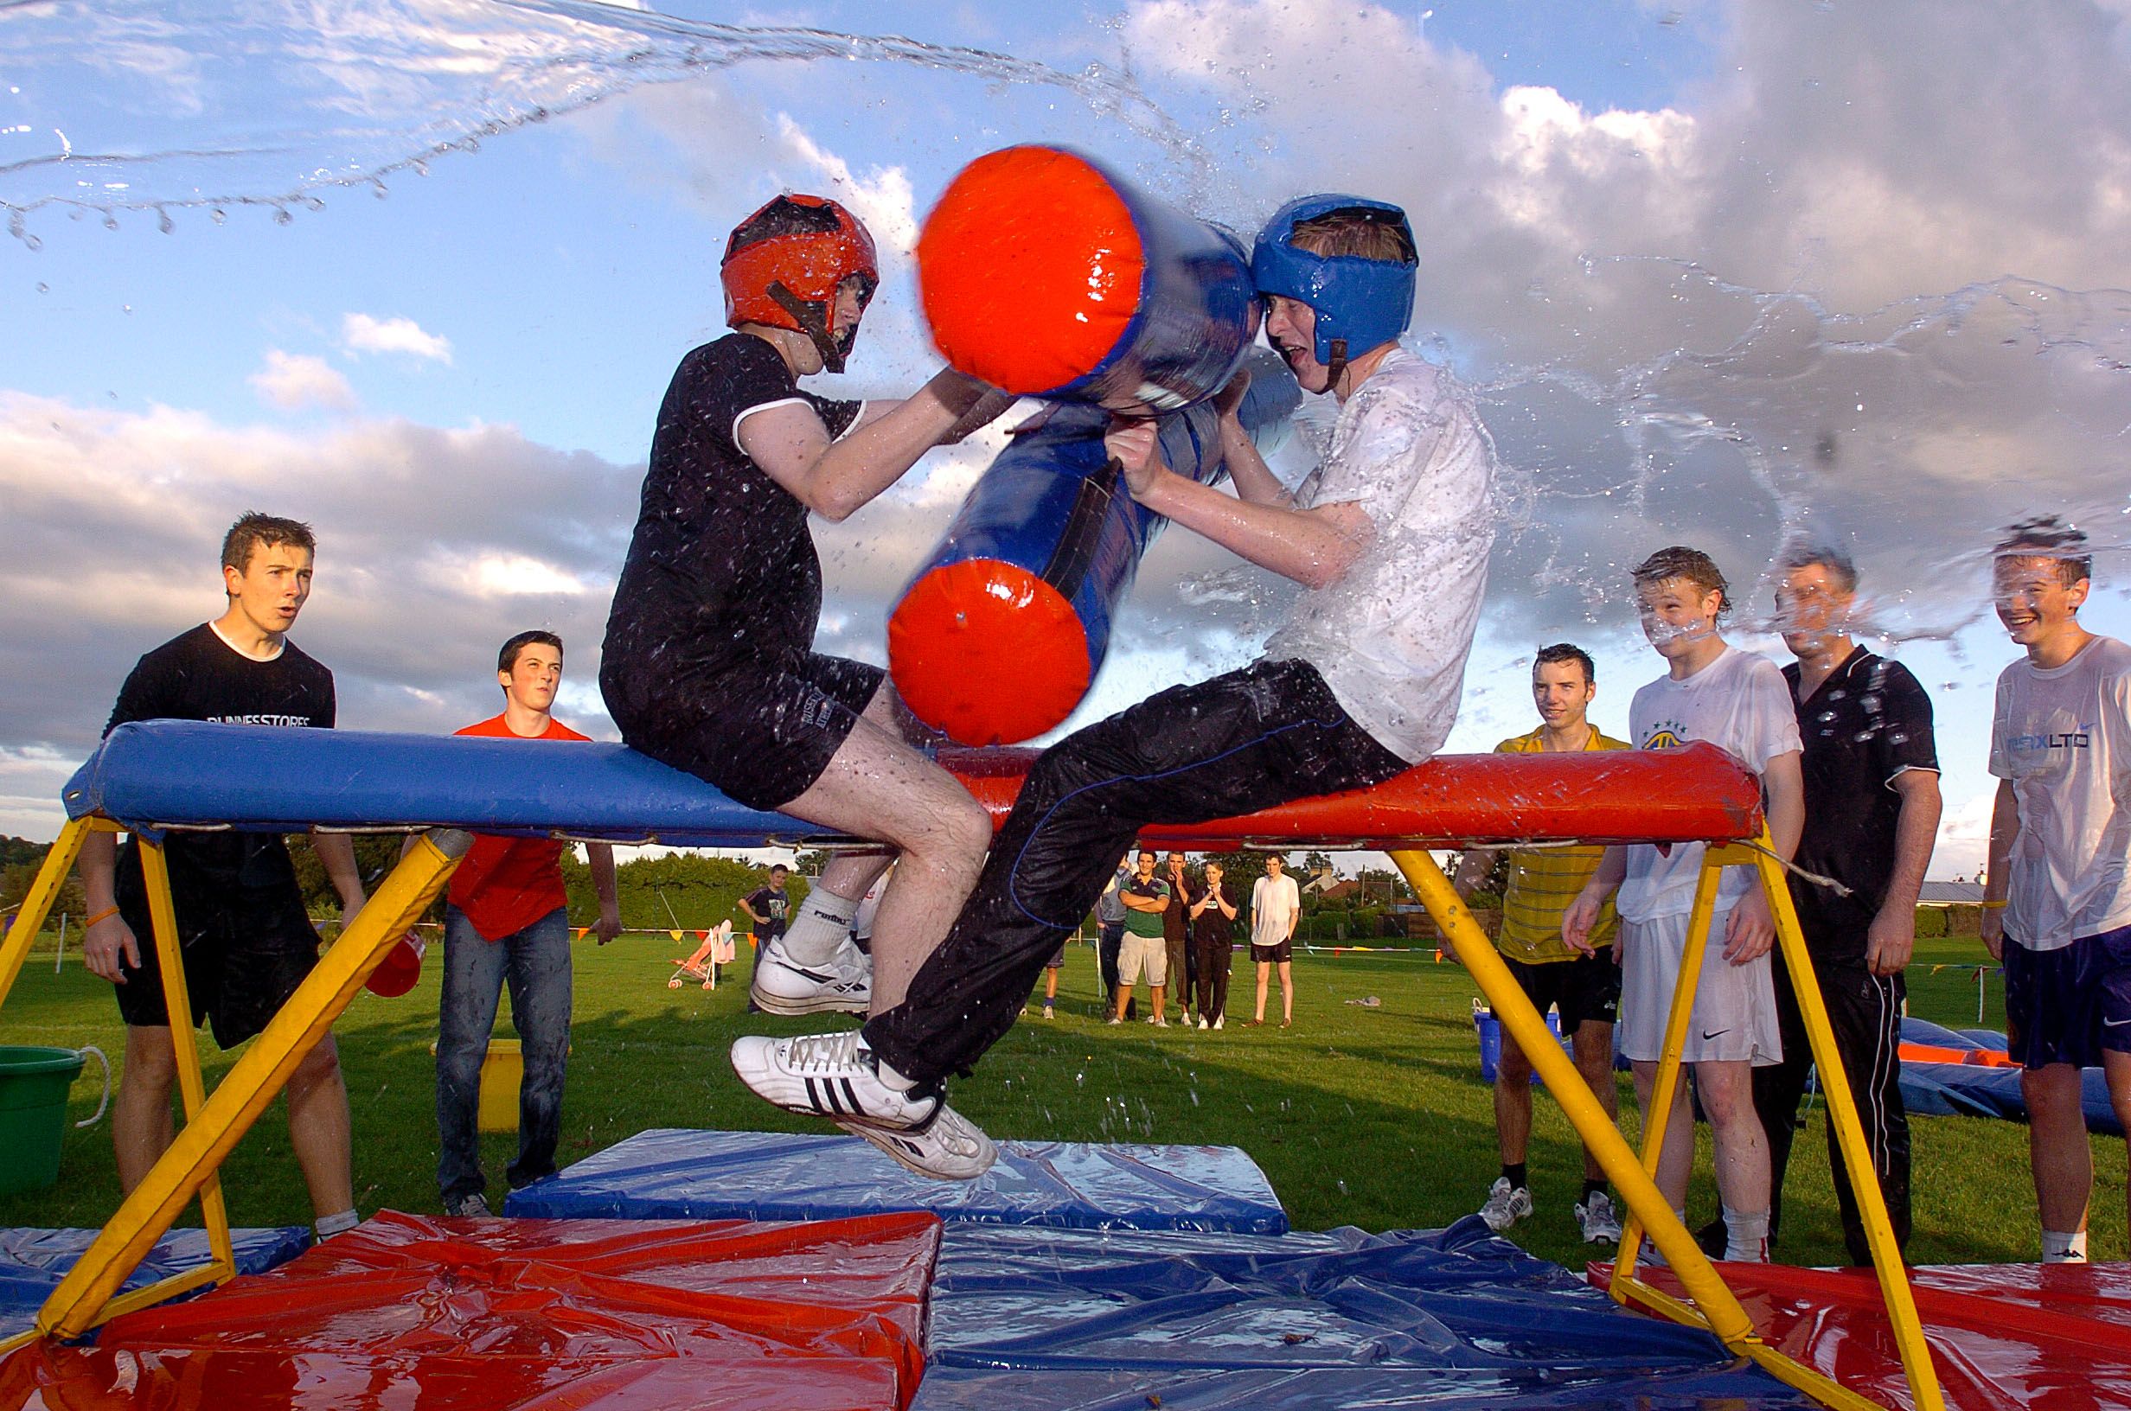

How To Take Part?
To help raise funds locally, we are recruiting a minimum of 10 teams made up of 8 people per team. Entry fee is £50.00 per team member. £100 deposit secures your team your place. All insurance, medical personnel and safety equipment is provided. Bring warm and practical clothing on the day, although we do encourage participants to dress as Pirates.

TO BE PART OF THIS EXCITING EVENT, SIMPLY FILL IN THE ENTRY FORM ENCLOSED AND RETURN IT TO LOUGH NEAGH RESCUE.

Lough Neagh Rescue Charity Ref. No XR14170
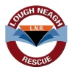
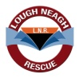
Lough Neagh Rescue Charity Ref. No XR14170
FUNDRAISING FUNDRAISING MADE EASY!

How you raise your sponsor money is up to you but here are a few ideas:

SPONSOR SHEETS
Lough Neagh Rescue will supply sponsor sheets on request. This way you can offer your friends and neighbours the opportunity to make a donation and show their commitment to a worthy cause.

SPECIAL EVENTS
If you have a good idea for raising funds Lough Neagh Rescue can help you promote it for the best results. Perhaps your club or work colleagues will join in and make a team effort. So start thinking a bit and make your contribution a real bonanza for the Lifeboats!

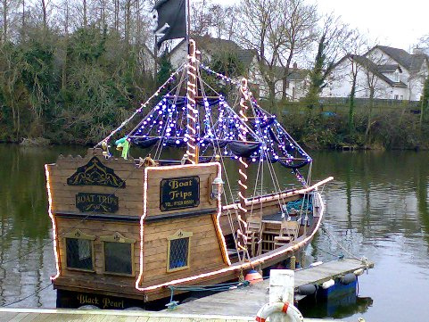
TEAM BUILDING
Your boss may be interested in this event.
Training and development managers for
example are always looking at new ways of
building team spirit and good morale in
the workplace.

BRING THE FAMILY-Why not bring family and friends along for a great day out and cheer your team along!

FOR FURTHER INFORMATION PLEASE CONTACT:

Tel: 07982 672434 (Trevor McKee)
Email: chairman@loughneaghrescue.co.uk
Lough Neagh Rescue
Kinnego Bay, Lurgan
Co. Armagh BT66 7NJ
www.loughneaghrescue.co.uk

About Lough Neagh Rescue
Lough Neagh is the largest lake in the British Isles being approx 20 miles long and 9 miles wide. It is generally shallow with an average depth in the main body of the Lough of 30′(9m) but very shallow round the margins of the Lough. The Lough is very exposed and in windy conditions it can become extremely rough very quickly. It is used extensively by a wide variety of recreational and commercial craft.
Mission
“LNR is the first response, Search and Rescue Lifeboat Service committed to preserving and saving life on Lough Neagh and its associated waters “
In addition:
“LNR is committed to working in partnership with other agencies to achieve our mission”.
Vision
LNR’s vision is a future where:
- Safety and navigation are prime responsibilities of each and every user.
- Lough Neagh is a safe environment for work, recreation and leisure.
- The protection of life on Lough Neagh’s waters is enshrined in legislation and resourced adequately.
- That LNR is a secondary SAR agency for the Northern Region.
- That LNR remains a voluntary and charitable organisation.

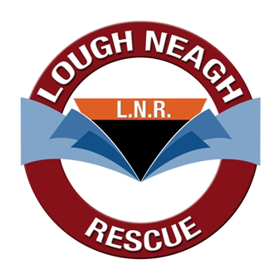
The Pirates are coming to Antrim!

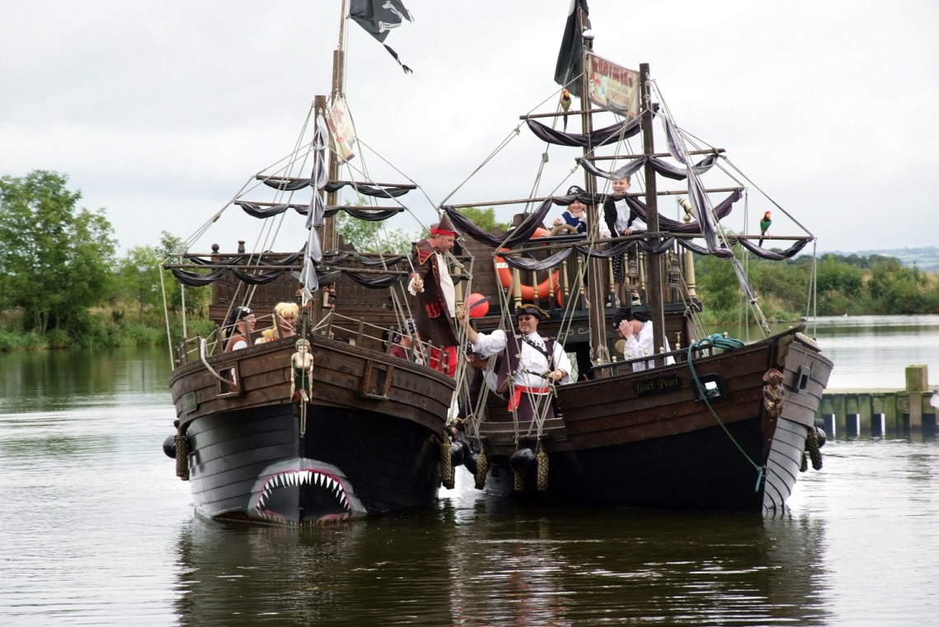

Join the Lough Neagh Rescue Team Building Experience

Lough Shore Park, Antrim
SATURDAY 12TH JUNE 2010: 12 Noon – 5pm

Don’t miss the ‘Knock-Out’ Challenge where the true Pirates will be revealed!

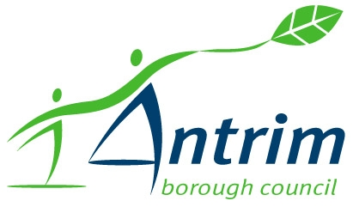
Supported by:

